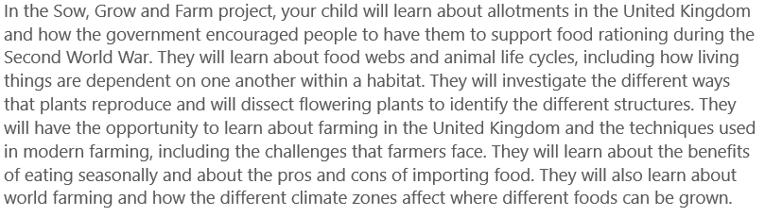
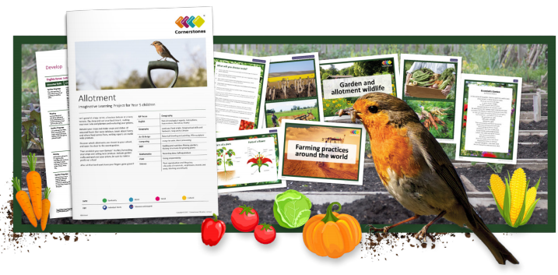
Maths | Literacy | Science
We will be continuing our Fractions learning. learning about decimals and percentages and also learning about geometry. | We will be writing diaries, creating our own leaflets and writing balanced arguments. | We will be studying food chains and webs; life cycles; plant reproduction; growing plants and modern farming.
P.E | R.E/PSHE | Geography
 | In PSHE we will be learning about relationships and how to have good communication in relationships with friends, peers and adults. | We will be learning about land uses and farming in the UK, physical features of North and South America, grid references and food transportation.
History | Art and design | Design and technology
We will be learning about the ‘Dig for Victory’ in WW2. | We will be studying still life artists and creating our own still life art. | We will be learning about what plants grow in the different seasons and have a go at growing our own seasonal fruit and veg.

