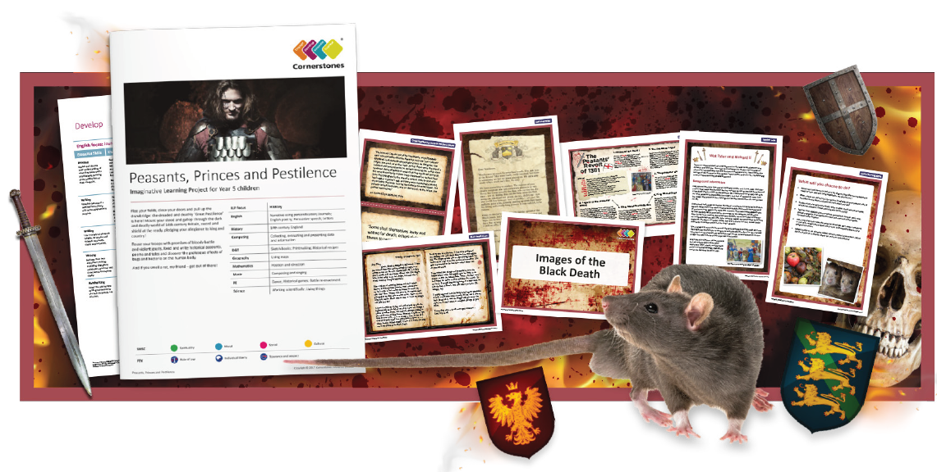
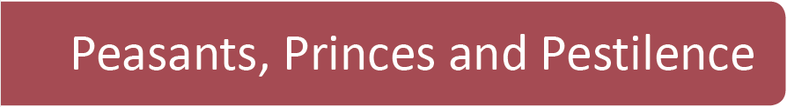
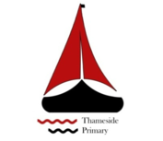

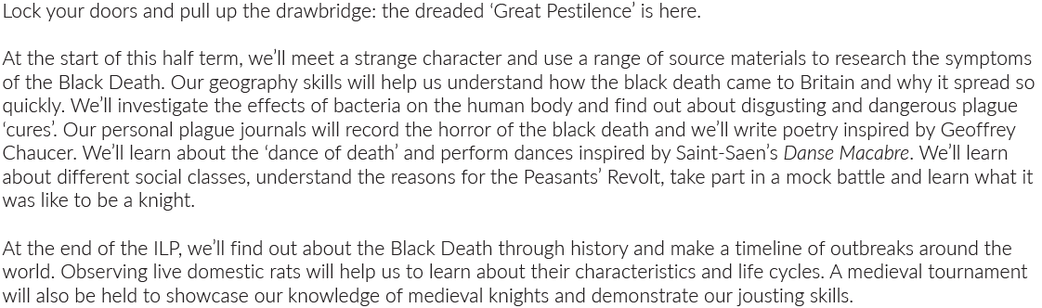
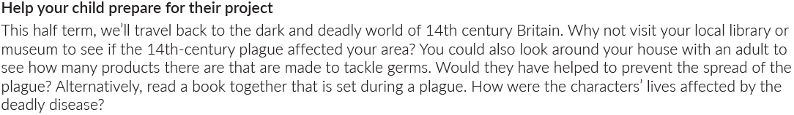
Maths | Literacy | Science
We will look at to continue multiplication and division as well as fraction this half term. | Short narrative / descriptive writing, diary writing and persuasive speech will be our topics this half term. | This half term we will look at materials investigating different properties of a range of materials and how these properties make them suitable for certain uses.
P.E | R.E/PSHE | Geography
 | We will be looking at health and wellbeing this half term. | We will look at maps of Europe this half term.
Computing | Design Technology | History
We will look at collecting, evaluating and presenting data. | We will look at Medieval recipes this half term. | We will look at the 14th century in England this half term.

