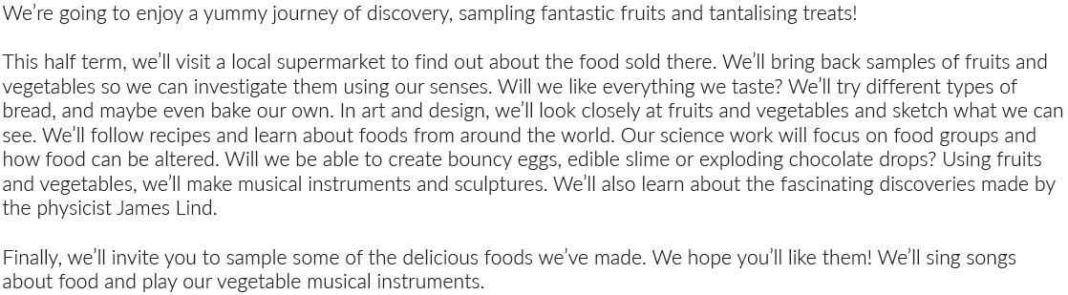
Maths | Literacy | Science
- Fractions  - Money  - Time | - Recipes  - Non-Chronological reports  - Fictional story writing  - Poetry with rhyme | How does your garden grow?  - What does a plant need to survive?  - Why are roots important?  - Seeds and dispersion  - Why are bees important?
P.E | R.E/PSHE | History
- Outdoor sports | PSHE  - Changes to our bodies  - Gaining help from emergency services | - Significant individuals- James Lind
Geography | Computing | Art and design
- Food miles  - Fair Trade | Animation  - Making images move  - Discussing frames  - Evaluating your production | - Shading techniques  - Observational drawings
Design technology | Music | RE
- Cooking and nutrition | - Playing instruments | - The importance of praying  - How people pray in other religions

