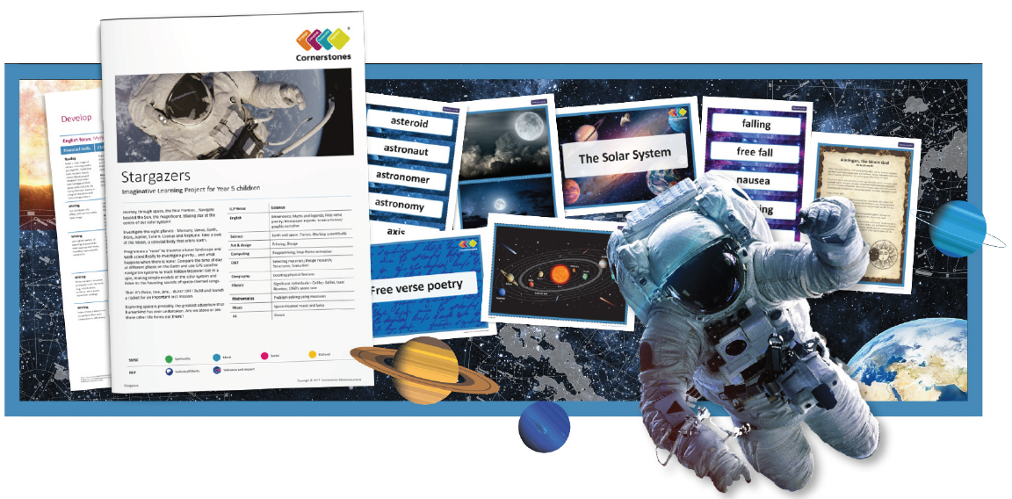
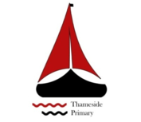

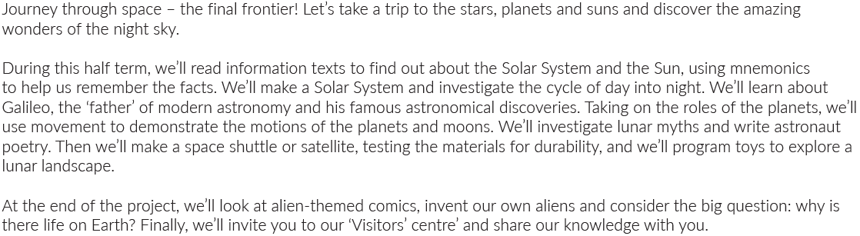

Maths | Literacy | Science
This half term we will look at statistics, multiplication and division and perimeter and area. | We will be writing free verse poetry, newspaper reports and descriptions. | We will be learning and investigating earth and space as-well-as forces.
P.E | R.E/PSHE | Geography
 | This half term we will think about our health and wellbeing and look at dealing with death and grief. | We will be locating physical features using a range of aerial images of the Earth to identify geographical features.
History | Art and Design / DT | Computing
We will look at significant individuals such as Galileo, Galilei, Isaac Newton and the 1960’s space race! | We will look at phases of the moon and use printing blocks to create a lunar chart based on the phases of the Moon over a month. We will also design and make a satellite, rover or shuttle for a specific mission | Explore programming by sequencing a series of instructions for programmable toys

