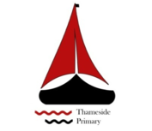

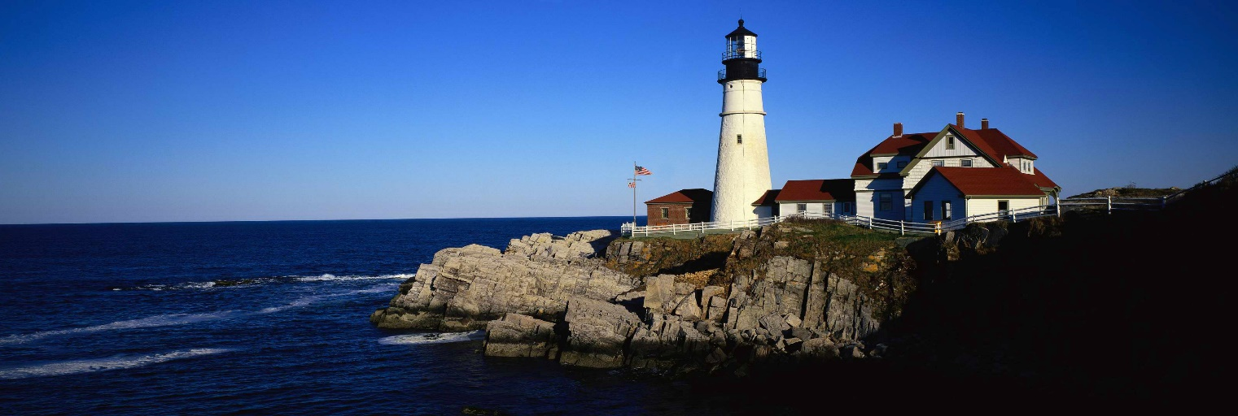
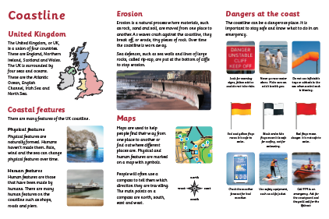
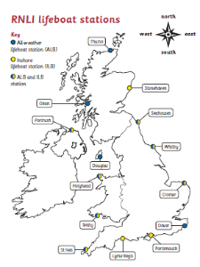
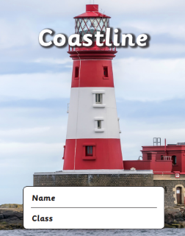
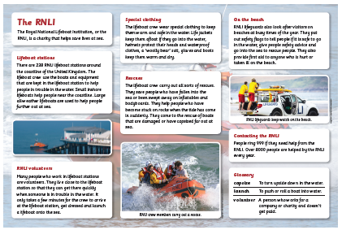
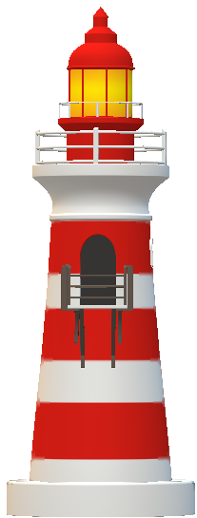
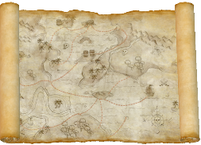
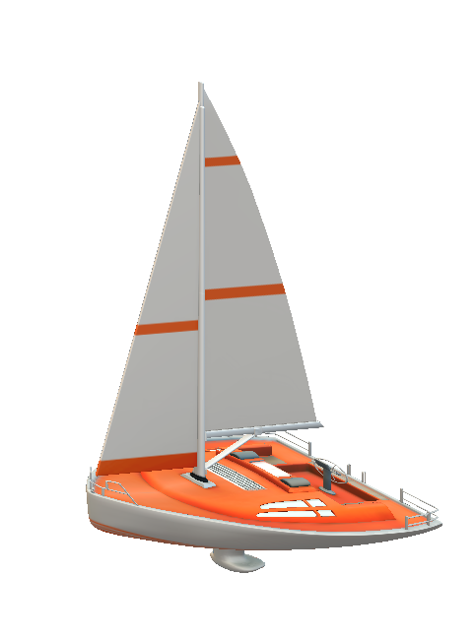
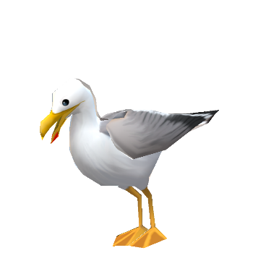

This half term in Year 2 we will be learning about physical and human features of the United Kingdom. We will use local maps to locate and name places along the River Thames and world maps to locate and name the oceans and continents. We will find out about the work of the RNLI, the organisations that keeps us safe at sea. We will find out about the life of Grace Darling in history. Science investigations will be linked to our watery theme. A pirate fun day will finish off this half term’s topic.
Maths | Literacy | Science
Place value  Fractions of shape and number  Addition and subtraction  Position and direction | Narrative: Fantasy story  Biography:The life of Grace Darling  RNLI non-chronological report  Water poems | Testing materials - Sink or float  Plasticine boats  Making rafts that float  Seashore habitats  Erosion investigation  Growing up
P.E | R.E/PSHE | Music
Athletics  Rounders  Cricket | Caring for our world  Stories Jesus told  Friendships: anti- bullying  Fairness and communities  Growing up and changing. | Sea shanties  Responding to music with sea and water themes.
Geography | History | Art and DT
River Thames – locating towns and cities  RNLI – locating stations around the UK  World map – locate continents, oceans, poles  Treasure maps – co-ordinates | Famous person or event - Grace Darling  RNLI timeline  Local history: Grays Beach present and past | Painting to music – ripple patterns  Observational drawing-shells.  Collage-layers of the ocean.  Raft building- designing and testing a product.

