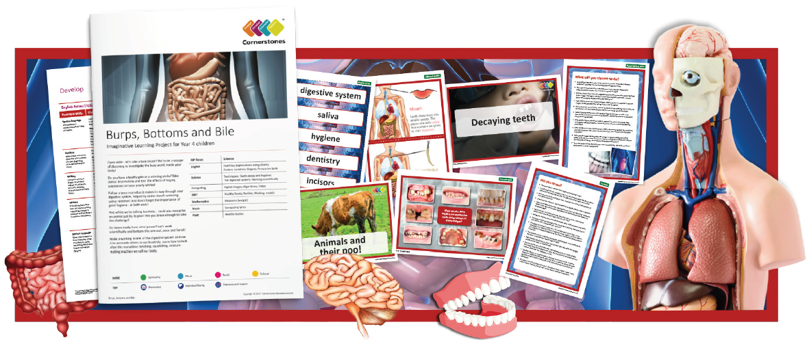
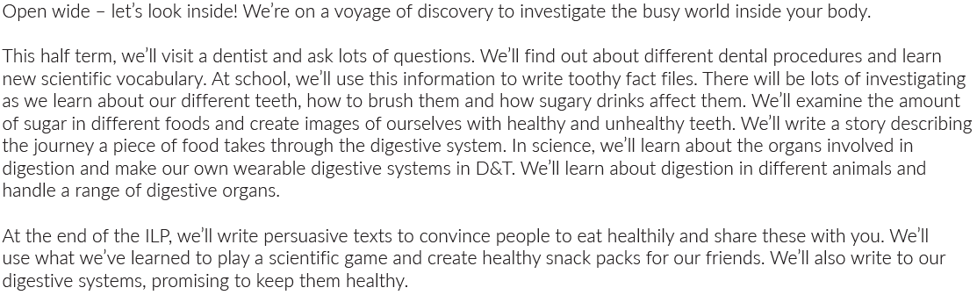

Maths | Literacy | Science
Number and Place Value  Rounding of numbers  Addition and subtraction | Fantasy narrative  Non-fiction fact files-Parts of the Body  Explanation texts- The Digestive System | Teeth types  The Digestive System
P.E | PSHE | Computing
Football or Netball  All of year 4 will be doing Cross Country. | Online Privacy; Internet Use; Gender stereotypes. | Images; Algorithms; Videos  Producing and Recording film clips
R.E | Music | Design and Technology
Why are festivals important to religious communities?- | Song Lyrics  Investigating songs about the body | Working models; healthy foods  3D model of The Digestive System

