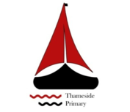

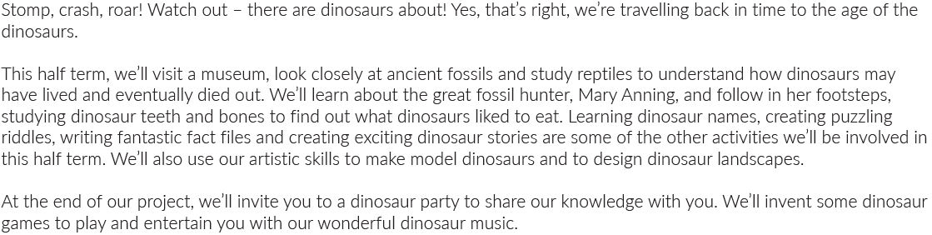
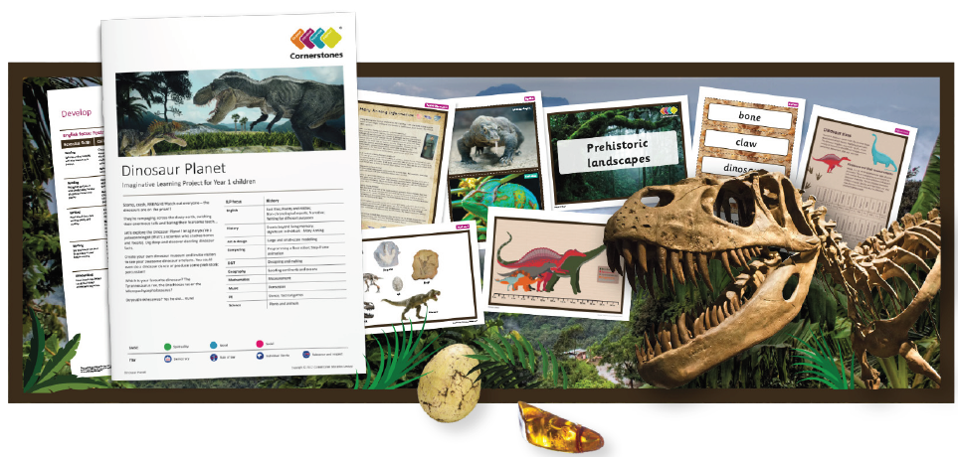

Maths | Literacy | Science
We will be learning all about measurements: length, height, weight and volume. | We will be making fact books all about dinosaurs. Writing a dinosaur story and thinking about describing dinosaurs. | We will be learning all about plants.
P.E | R.E/PSHE | History
Pupils will be learning Athletics, Rounders and Cricket in PE this term. | We will be learning to develop our skills by learning about at fairness, family and friends and rules and responsibilities.  We will be learning about what we all celebrate, special and sacred times. | We will be learning all about dinosaurs and how Mary Anning discovered them.
Art and design | Computing | DT
We will be experimenting with large and small scale models of dinosaurs using clay and looking at their habitat. | We will be developing our skills with the beebots and exploring other technology to help us learn. | We will be making a model of a dinosaur. And exploring prehistoric landscapes.
Geography | Music
We will be locating continents and oceans. | We will be looking at and using percussion instruments.

