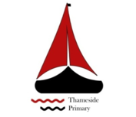
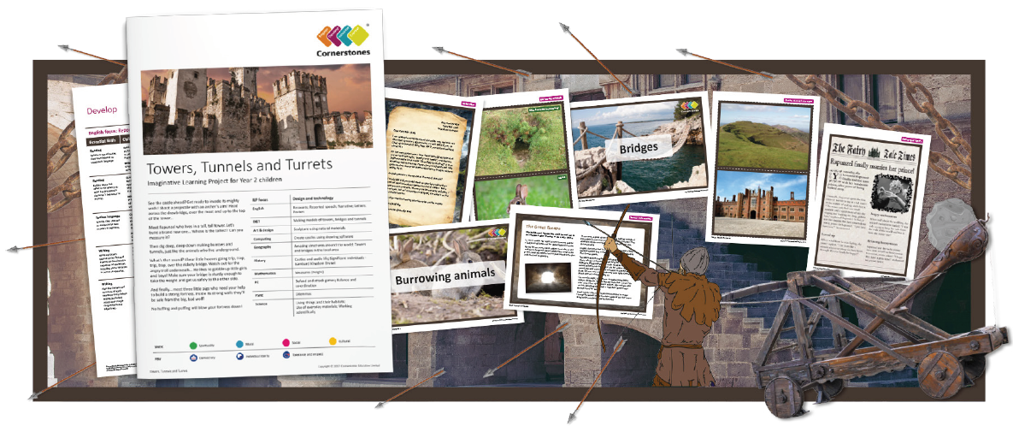

Climbing the battlements or tunnelling in the ground, there’s a whole world of adventure to be found!
This half term we will learn about different parts of a castle and how they were built. We will build models and experiment with different materials, to find which materials are strong and which are weak. We’ll learn about the tallest buildings and longest tunnels in the world. We will find out about the amazing Victorian engineer, Isambard Kingdom Brunel and why he is so important to our transport links today.
An online presentation will again show off our new knowledge and skills learnt throughout the project.

Maths | Literacy | Science
Data handling, 2D & 3D shape, time, fractions | Fantasy story,  Non-chronological report – Brunel  Recount | Building structures, predicting and testing to destruction!
P.E | R.E/PSHE | History
 | The human body, physical exercise | Famous inventors - Brunel
DT | Art | Music
Building structures with a variety of materials | Artists and architects – Seurat, Monet, Gaudi, Klee, Rizzi | Creepy castle, the Grand old Duke of York, The king is in his castle
