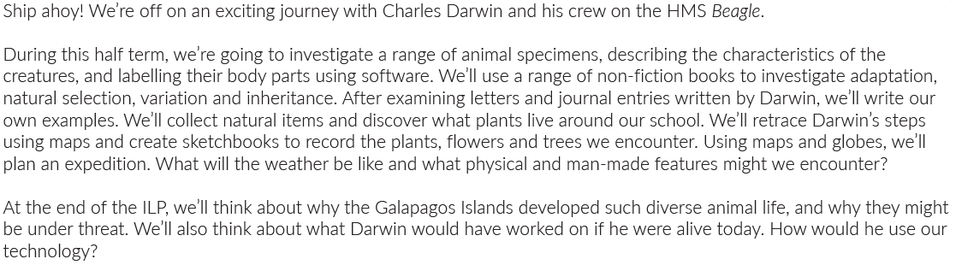
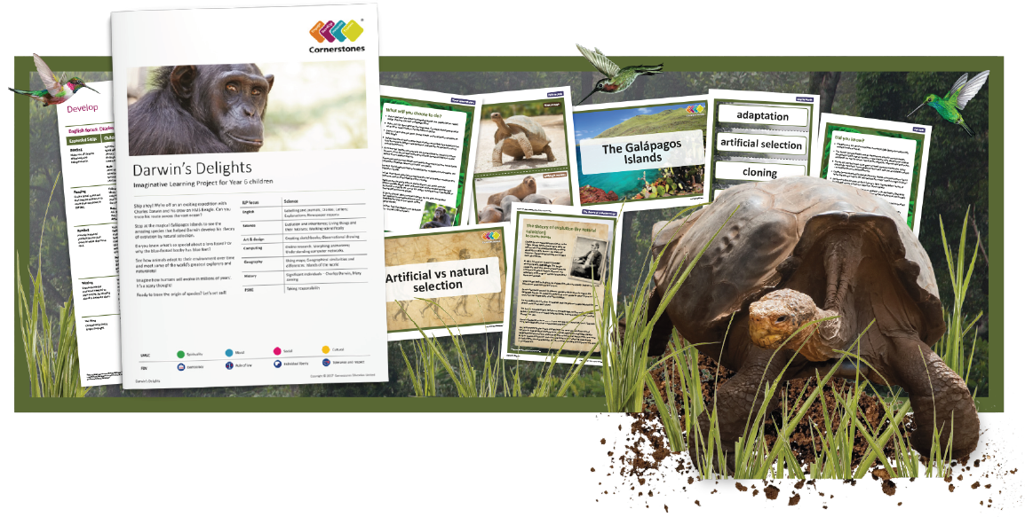
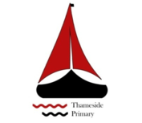
Maths | Literacy | Science
In Maths, we will be learning about perimeter, area and volume. | In English, we will be learning to write diary entries in the role of Charles Darwin about his experiences on the Galapagos Islands and writing a biography about Charles Darwin. | In Science, we will be learning about Evolution and inheritance: living things and their habitats.
P.E | R.E/PSHE | Geography
In PE, we will be focussing on fitness and core skills development for team games. | Healthy Minds  Mental wellbeing  Support and care | In Geography, we will be looking at Geographical maps as well as the Geographical similarities and differences for Islands of the world.
Computing | Art and Design | History
In Computing, we will be completing Online research, Morphing animations and learning about computer networks. | In Art, we will be learning to complete observational drawing and creating sketchbooks. | In History, we will be learning about significant individuals including: Charles Darwin and Mary Anning.
