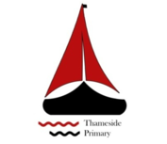
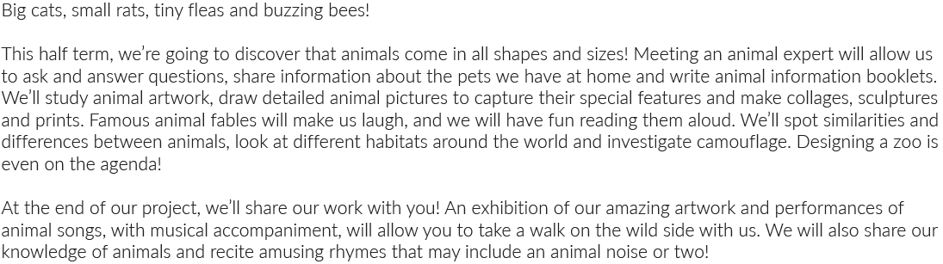
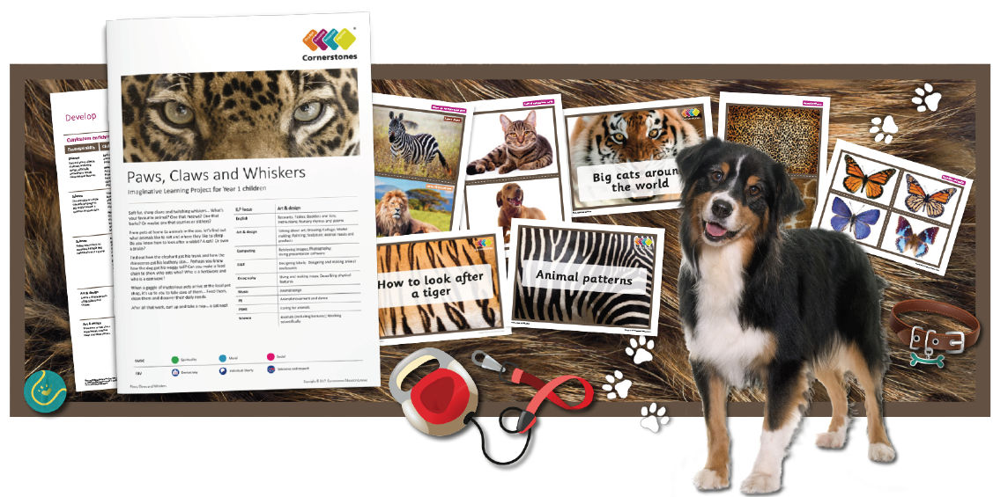
Maths | Literacy | Science
We will be counting in 2’s and 5’s. Comparing objects and numbers within 50. We will also be comparing length, weight and height. | Fiction: Story with a familiar setting-sequenced  Non-Fiction: Information-Animal groups  Poetry: Riddles/Animal characteristics | We will be looking and learning about animals in our environment.
P.E | R.E/PSHE | Art and Design
We will be doing fitness trying to keep all pupils physically active. We will also be looking at core skills. | We will be thinking about our families and being kind to others. | We will be drawing different animals using different techniques including collage and sketching.
Computing | DT | Geography
We will be selecting and retrieving images to support our learning. | We will be designing and making an animal enclosure. | We will be using and making maps as well as describing a physical feature.
Music
We will be learning to perform various animal songs.

