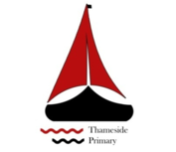

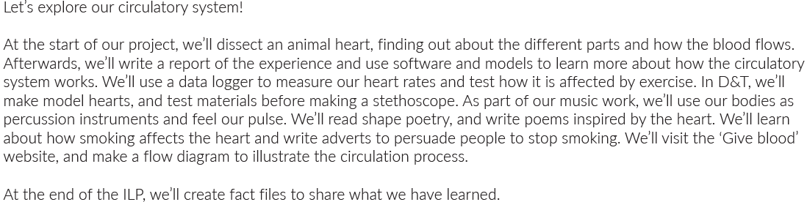
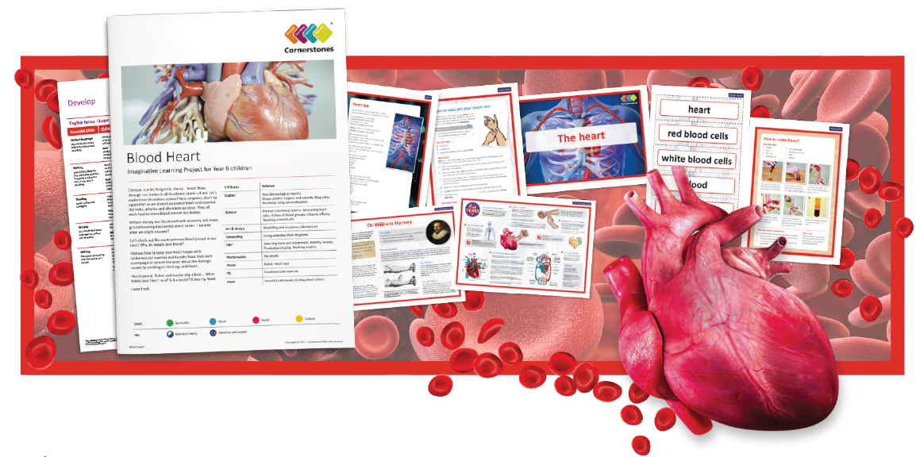

Maths | Literacy | Science
In Maths, we will be learning about Place Value including numbers to ten million, rounding numbers, negative numbers and using and applying the four operations. | In English, we will be writing a set of instructions about how to dissect a heart as well as writing an explanation and persuasive text. In addition to this, we will be writing a narrative about the journey of a red blood cell | In Science, we will be learning about the Circulatory system as well as measuring our heat rate and learning about healthy lifestyles.
P.E | R.E/PSHE | Computing
In PE, we will be learning football or netball skills and applying these too game situations.  All of year 6 will be doing cross country working on their fitness and pace. | In RE, our key learning enquiry question is: What do religions say to us when life gets hard?  In PSHE, we will be learning about harmful substances and caring about others. | In Computing, we will be learning about flow diagrams to model the circulation process.
Art and Design | Music | Design and Technology
In Art and design, we will be making a model of a human heart as well as creating abstract art. | In Music, we will be learning how to keep a pulse and to distinguish between the timbre and texture of instruments. | In Design and Technology, we will be learning to plan and design a model heart and test materials before making a stethoscope.

