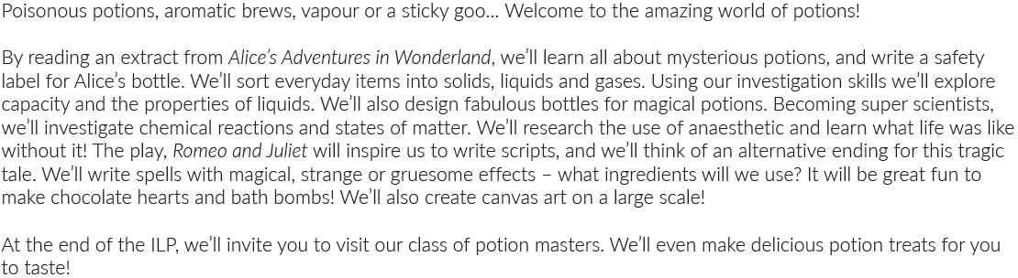
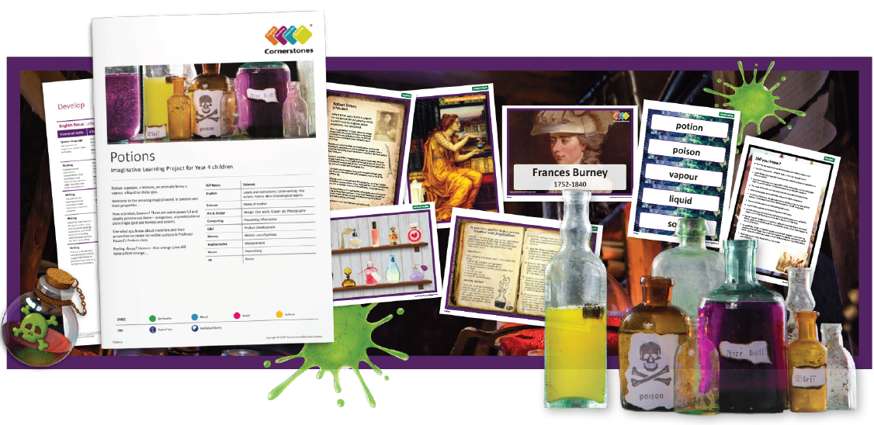
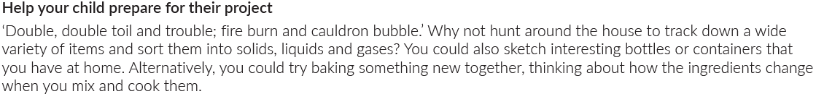
Maths | Literacy | Science | Art
Decimals  Money  Time  4 Number rules | Play scripts  Diary Writing  Persuasive adverts | Materials  States of Matter | Painting  Use of Photography
P.E | PSHE | History | Computing
Athletics  Cricket  Rounders | Setting goals  Identifying strengths | Historic use of potions  Famous people in History | Changing digital images
R.E | Design and Technology | Music
Life is a journey  Christianity/Judaism/Hindu | Developing products  Creating a potion | Improvisation  Music appreciation

