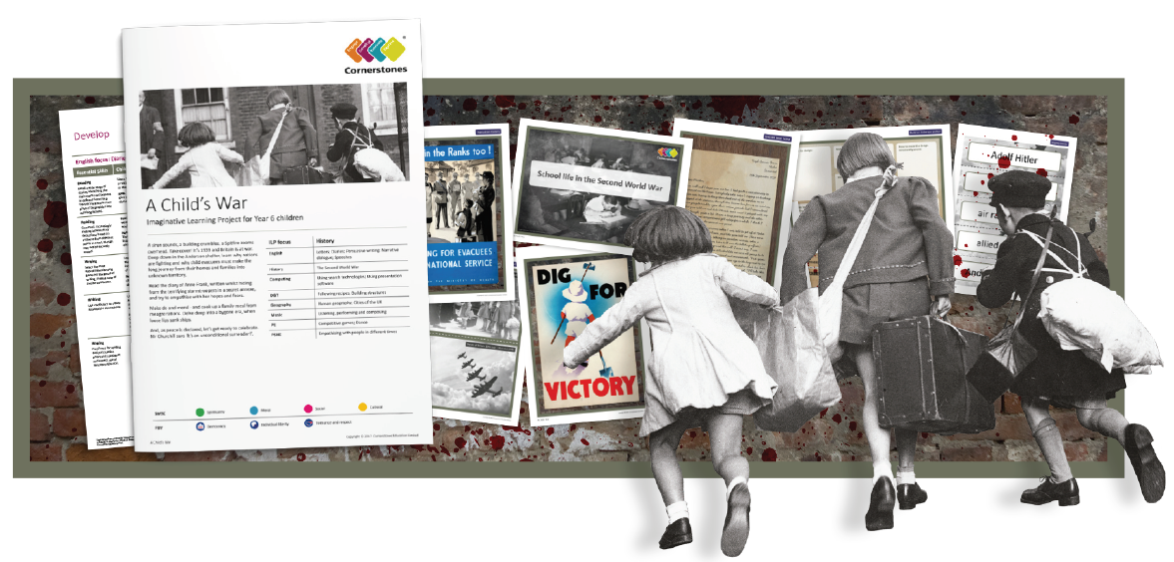

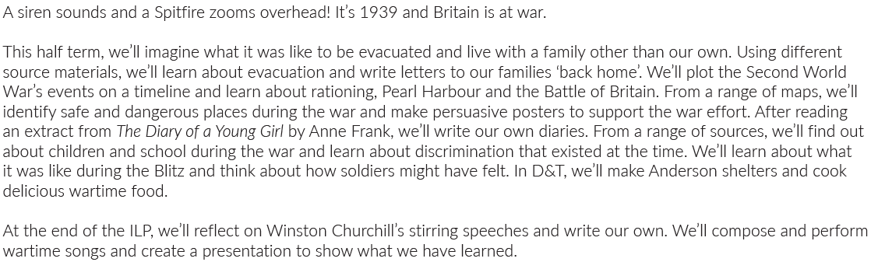

Maths | Literacy | Science
In Maths, we will be learning about the order of operations (BIDMAS), adding and Subtracting Fractions, multiplying Fractions by integers and the four rules of fractions. | In English, we will be writing a Biography about Winston Churchill as well as writing a diary entry about experiences in the London Blitz and writing informal letters capturing the thoughts and feelings of soldiers from the frontline. | In Science, we will be learning about what it means to be healthy, to know how food is divided into different food groups and the benefits of exercise overtime.
P.E | R.E/PSHE | Geography
In PE, we will be developing our netball skills as well as taking part in cross country running and fitness. | In PSHE, we will be learning how to empathise with people in different times. | In Geography, we will be using United Kingdom maps to locate areas where children were evacuated to as well as major cities that were targeted by German air raids.
History | Design and Technology | Computing
In History, we will be learning about the significance of key events in the Second World War including: rationing, Pearl Harbour and the Battle of Britain. We will also be learning about evacuation and significant political leaders who led throughout World War Two. | In Design and Technology, we will be learning to make popular wartime foods from recipes. In addition to this, we will be using a range of materials to design and construct Anderson Shelters. | In computing, we will be using search technologies to research information about the Battle of Britain and creating own presentations on the historical content.
Music | Art and Design
In Music, we will be learning about different musical styles including learning how to sing and perform wartime songs. | In Art and Design, we will be using different watercolour techniques to create our own ‘wash’ for a backdrop for our London Blitz Art. We will be using and applying collage techniques to create a London Blitz scene.

