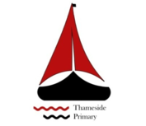

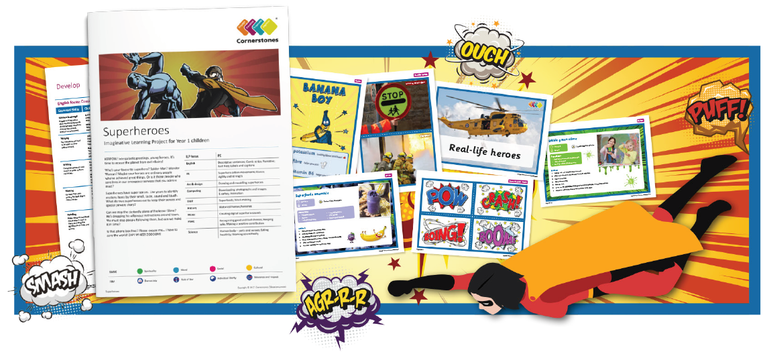
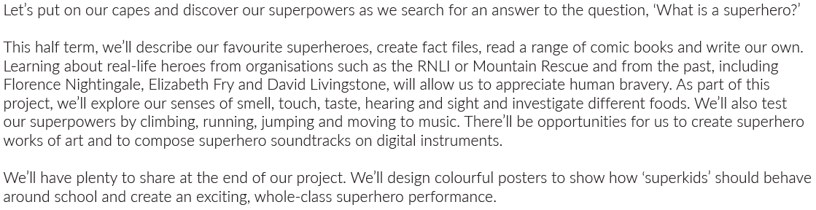
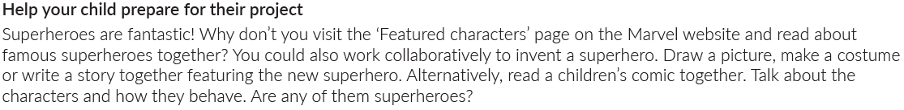
Maths | Literacy | Science
We will be focusing on shapes and number with place value up to 20. | We will be learning to write about a story with a familiar setting.  We will be writing descriptions, Comic strips, Narratives, fact files, labels and captions. | We will be using our senses to explore our environment and different materials.
P.E | R.E/PSHE | History
We will be using our Superhero action movements using our agility and strength. | We will be thinking about how to use our manners, feelings and sharing our opinions. | Historical heroes and Heroines will be our focus for History. We will be learning about Florence nightingale and Sir Rober Peel.
Computing | Art and design | Design and technology
We will be learning to download photographs and images. Our focus will also be on E-safety and animation. | We will also be drawing and modelling superheroes. | We will be making our superhero costumes and looking at super foods!
Music
Superhero sounds will be our focus.

